
EAST WEST UNIVERSITY
Masters in Data Science and Analytics
Session: Fall 2025
Time Series Analysis (DSA-5021)

Time Series Analysis Course Project

Submitted by: |  |  | Submitted to:
Name | : | Mahmud Hasan Khan | Professor Dr. Md Rezaul Karim
Student ID | : | 2025-1-83-005 | Department of Data Science and Analytics
Session | : | Fall – 2025 | East West University

16 December 2025
Contents
Executive Summary: iv
1 Overview: 1
2 Dataset Description: 1
3 Analysis Model Building and Evaluation: 1
3.1 Part-1: Exploratory Data Analysis: 1
3.1.1 Retail Sales: 1
3.1.2 Energy Consumption: 3
3.1.3 Stock Price Index: 5
3.1.4 Unemployment Rate Over Time: 7
3.2 Part-2: Unit Root Testing 9
3.2.1 Retail Sales 9
3.2.2 Energy Consumption: 11
3.2.3 Stock Price Index 12
3.2.4 Unemployment Rate 14
3.2.5 Summary Table of the Unit Root Test 15
3.2.6 Conclusion on Unit Root Test: 15
3.3 Part 3: ARIMA Modeling 16
3.3.1 ARIMA Modeling on Retail Sales 16
3.3.2 ARIMA on Stock Price Index 18
3.4 Part 4: SARIMA Modeling 19
3.5 Part 5: Exponential Smoothing Models: 23
Conclusion: 25

List of Tables:
Table 1: Descriptive Statistics of Retail sales 1
Table 2: Descriptive Statistics of Energy Consumption 3
Table 3: Descriptive Plot of Stock Price Index 5
Table 4: Descriptive Statistics of Employment Rate 7
Table 5: ADF Test Results of Retail Sales (Level) 9
Table 6: KPSS Test Results of Retail Sales (Level) 9
Table 7: ADF Test Result of Retail Sales (First Differencing) 10
Table 8: KPSS Test Result of Retail Sales (First Differencing) 10
Table 9: ADF Test Result of Energy Consumption (Level) 11
Table 10: KPSS Test Result of Energy Consumption (Level) 11
Table 11: ADF Test Result of Energy Consumption (First Differencing) 11
Table 12: KPSS Test Result of Energy Consumption (First Differencing) 12
Table 13: ADF Test Result of Stock Price Index (Level) 12
Table 14: ADF Test Result of Stock Price Index (Level) 13
Table 15: ADF Test Result of Stock Price Index (First Differenced) 13
Table 16: ADF Test Result of Stock Price Index (First Differenced) 13
Table 17: ADF Test Result of Unemployment Rate (Level) 14
Table 18: KPSS Test Result of Unemployment Rate (Level) 14
Table 19: ADF Test Result of Unemployment Rate (First Differenced) 15
Table 20: KPSS Test Result of Unemployment Rate (First Differenced) 15
Table 21: Summary Table of Unit Root Test of all series 15
Table 22: ARIMA models comparison 16
Table 23: ARIMA models of Stock Price Index comparison with AIC 18
Table 24: Comparison Table of ARIMA and SARIMA models 21
Table 25: Comparison of ES models 23
Table 26: Comparison table of Best performing models of ES and SARIMA 24
List of Figures:
Figure 1: Plot of Time vs Retail sales 1
Figure 2: ACF and PACF Plot of Retail sales 2
Figure 3: Decomposition Plot of Retail Sales 2
Figure 4: Plot of Time vs Energy Consumption 3
Figure 5: ACF and PACF Plot of Energy Consumption 4
Figure 6: Decomposition plot of Energy Consumption 4
Figure 7: Plot of Stock Price Index vs Time 5
Figure 8: ACF and PACF Plot of Stock Price Index 6
Figure 9: Decomposition Plot of Stock Price Index 6
Figure 10: Plot of Unemployment Rate vs time 7
Figure 11: ACF and PACF Plot of Unemployment Rate 8
Figure 12: Decomposition Plot of Unemployment Rate 8
Figure 13: ACF and PACF Plot of Retail Sales at d = 1 16
Figure 14: Diagnostic Plot of ARIMA (6,1,6) of Retail sales. 16
Figure 15: Q-Q Plot of Residual for Retail Sales 17
Figure 16: Forecasting with ARIMA (6,1,6) 17
Figure 17: ACF and PACF Plot of Stock Price Index with d = 1 18
Figure 18: Diagnostic Plot of Stock Price Index ARIMA model (1,1,0) 18
Figure 19: Q-Q Plot of Residual of ARIMA (1,1,0) of Stock Price Index 19
Figure 20: Forecasting withARIMA (1,1,0) 19
Figure 21: Seasonal Differenced (D=1) ACF and PACF Plot of Energy Consumption 20
Figure 22: ACF and PACF of non-seasonal difference (d = 1) of Energy Consumption 20
Figure 23: Diagnostic Plot of ARIMA (2,1,3) for Energy Consumption 21
Figure 24: Diagnostic Plot of Energy Consumption SARIMA (0,0,0) (1,1,0)12 22
Figure 25: Q-Q Plot of Residual of SARIMA (0,0,0) (1,1,0)12 of Energy Consumption 22
Figure 26: Forecasting of Energy Consumption with ARIMA (1,1,0) and SARIMA (0,0,0) (1,1,0)12 23
Figure 27: Forecasting of Energy Consumption with SARIMA (0,0,0) (1,1,0)12 and ES (HW Additive) 24

Executive Summary:
Project Overview:
This report presents a comprehensive time series analysis of four key economic indicators—Retail Sales, Energy Consumption, Stock Price Index, and Unemployment Rate—over a 60-month period (January 2019 – December 2023). The objective was to identify underlying patterns, test for stationarity, and develop robust forecasting models to predict future trends.
Key Findings:
- Exploratory Data Analysis (EDA): Visual inspection and decomposition revealed distinct characteristics for each series. Retail Sales and Stock Price Index exhibited strong upward trends, indicating long-term growth. Energy Consumption displayed highly regular seasonality without a dominant trend, consistent with annual climate cycles. The Unemployment Rate showed volatility, particularly reflecting economic disruptions during the 2020–2021 period.
- Stationarity: Unit root testing (ADF and KPSS) confirmed that all four series were non-stationary at their level forms. Stationarity was achieved through first-order differencing ($d=1$), allowing for valid ARIMA and SARIMA modeling.
- Model Selection & Performance:
  - Seasonal vs. Non-Seasonal: For series with strong seasonal components, specifically Energy Consumption, the SARIMA model significantly outperformed non-seasonal ARIMA and Exponential Smoothing models. The SARIMA (0,0,0) (1,1,0) 12 model reduced the Root Mean Squared Error (RMSE) by nearly half compared to Holt-Winters, demonstrating the importance of explicitly modeling seasonal lags.
  - Trend Modeling: For Retail Sales, models incorporating trend components provided the best fit.
Conclusion:
The analysis confirms that while standard ARIMA models are sufficient for non-seasonal data like the Stock Price Index, complex seasonal patterns (as seen in Energy and Retail) require SARIMA specifications for accurate forecasting. The final selected models provide a reliable baseline for predicting future economic conditions, with the Energy Consumption model showing particularly high predictive accuracy due to the stability of its seasonal cycles.

Overview:
This project conducts a comprehensive univariate time series analysis on four distinct economic and business indicators. Specifically, this project aims to evaluate the predictive power of various forecasting methodologies. The analysis is an assessment of data properties, including stationarity testing, followed by the development of Autoregressive Integrated Moving Average (ARIMA), Seasonal ARIMA (SARIMA), and Exponential Smoothing (ETS) models. The final phase of the study involves a comparative performance analysis to determine the most robust forecasting framework for the selected data.

Dataset Description:
Provided dataset (time_series_project_data.csv) contains containing 60 months of observations (January 2019–December 2023) for four different time series: Retail Sales, Energy Consumption, Stock Price Index, and Unemployment Rate. The data seems uncorrelated and the task specifies to analyze the data in time series individually. The dataset provided with different date of the month. So, the data is conditioned to make the dataset a monthly data.

Analysis Model Building and Evaluation:

Part-1: Exploratory Data Analysis:

Retail Sales:
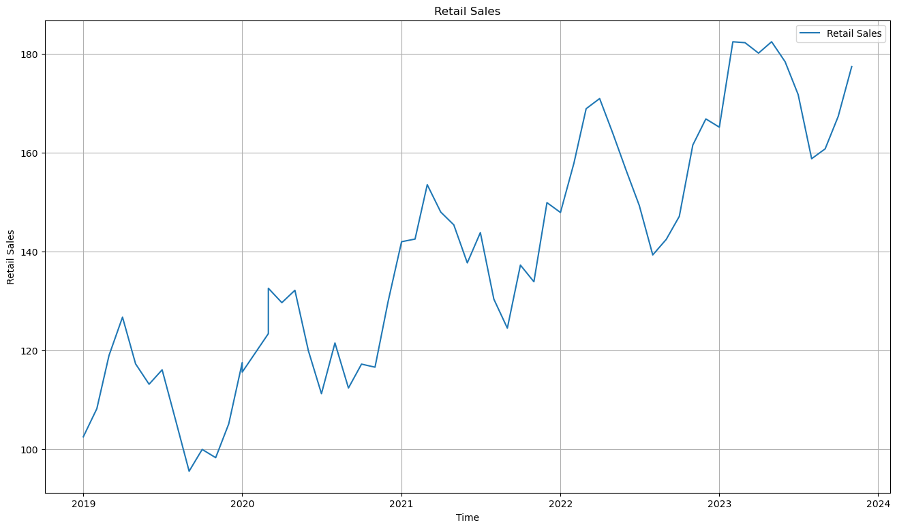
Figure 1: Plot of Time vs Retail sales
Description of pattern of Retail sales plot: Retail Sales shows a clear upward trend and seasonality, cyclic behavior is not apparent from the plot, also shows irregularity.
Descriptive Statistics:
Statistic | Retail Sales (Million USD)
Count | 60
Mean | 139.23
Median | 138.48
Std. Dev. | 24.63
Min | 95.51
Max | 182.42
Table 1: Descriptive Statistics of Retail sales
This series exhibits significant volatility, with a standard deviation of $24.63 million against a mean of $139.23 million. The wide range ($95.51M – $182.42M) suggests strong underlying fluctuations, likely driven by seasonal consumer behaviors or trends. The close proximity of the mean ($139.23) and median ($138.48) indicates a relatively symmetric distribution.
ACF and PACF Plot:
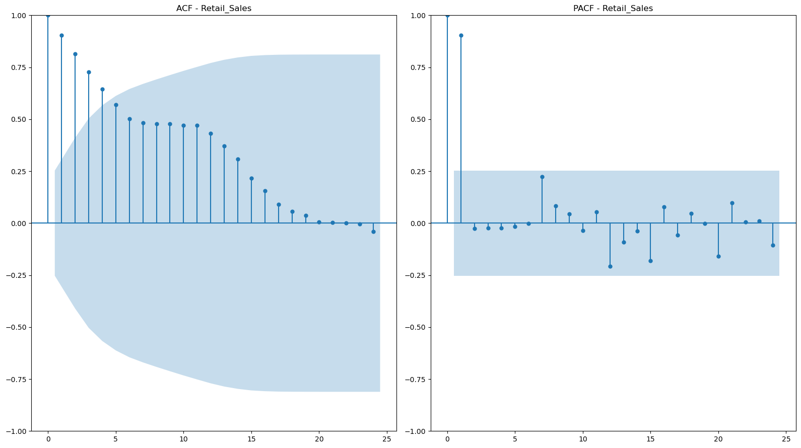
Figure 2: ACF and PACF Plot of Retail sales
Decomposition Plot:
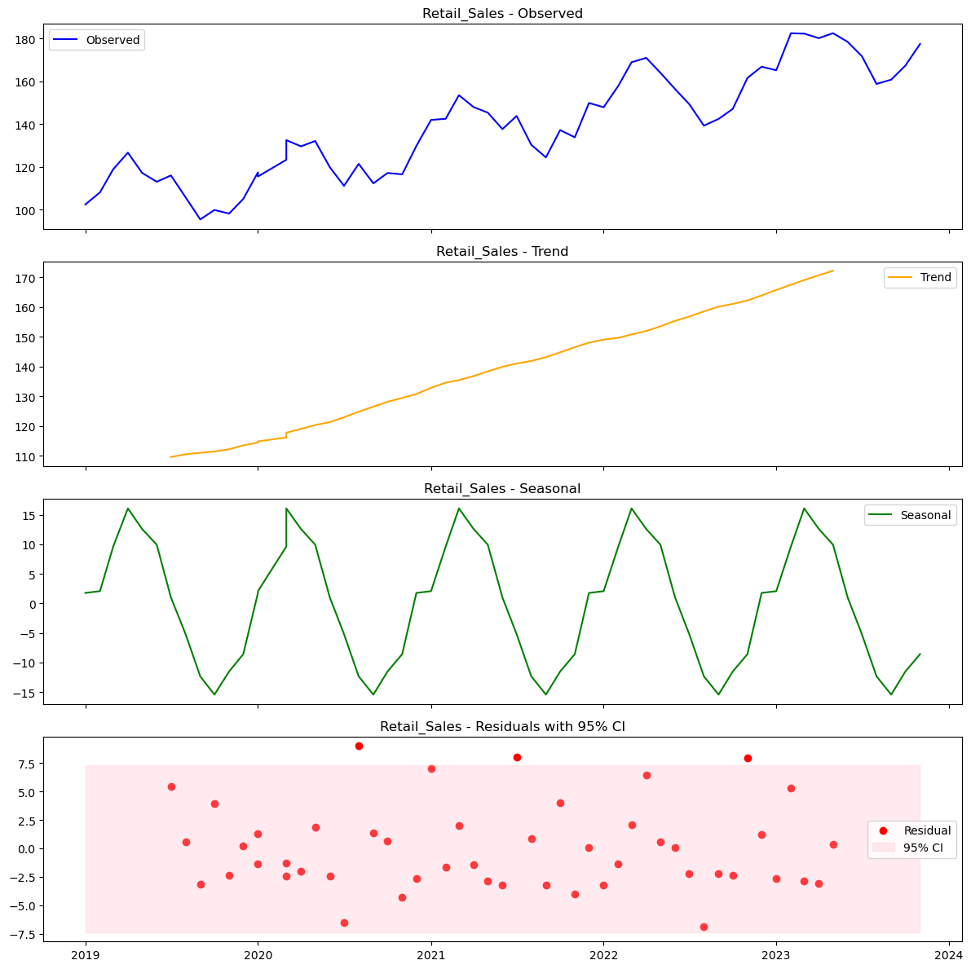
Figure 3: Decomposition Plot of Retail Sales
Comment on Decomposition: The decomposition of Retail Sales (2019–2023) reveals three distinct characteristics:
- Trend: A robust, linear upward trajectory indicating consistent market growth.
- Seasonality: A strong, repetitive annual cycle ($m=12$) with constant amplitude, confirming an Additive seasonal structure.
- Residuals: Largely stationary noise centered around zero, though minor outliers appear in 2021 and 2023.

Energy Consumption:
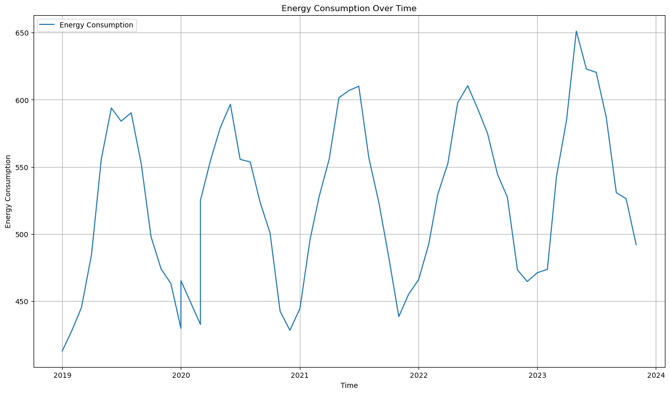
Figure 4: Plot of Time vs Energy Consumption
Description of pattern of Energy Consumption plot: Energy Consumption shows a Slight upward trend and dominant seasonality, cyclic behavior is not apparent from the plot, this plot also shows irregularity.
Statistic | Energy Consumption (GWh)
Count | 60
Mean | 524.94
Median | 527.55
Std. Dev. | 61.62
Min | 412.81
Max | 651.15
Table 2: Descriptive Statistics of Energy Consumption
Energy usage shows moderate variability with a standard deviation of 61.62 GWh. The median (527.55 GWh) is slightly higher than the mean (524.94 GWh), indicating a slight negative skew. The difference between the minimum (412.81 GWh) and maximum (651.15 GWh) values suggests substantial seasonal shifts in demand.
ACF and PACF Plot:
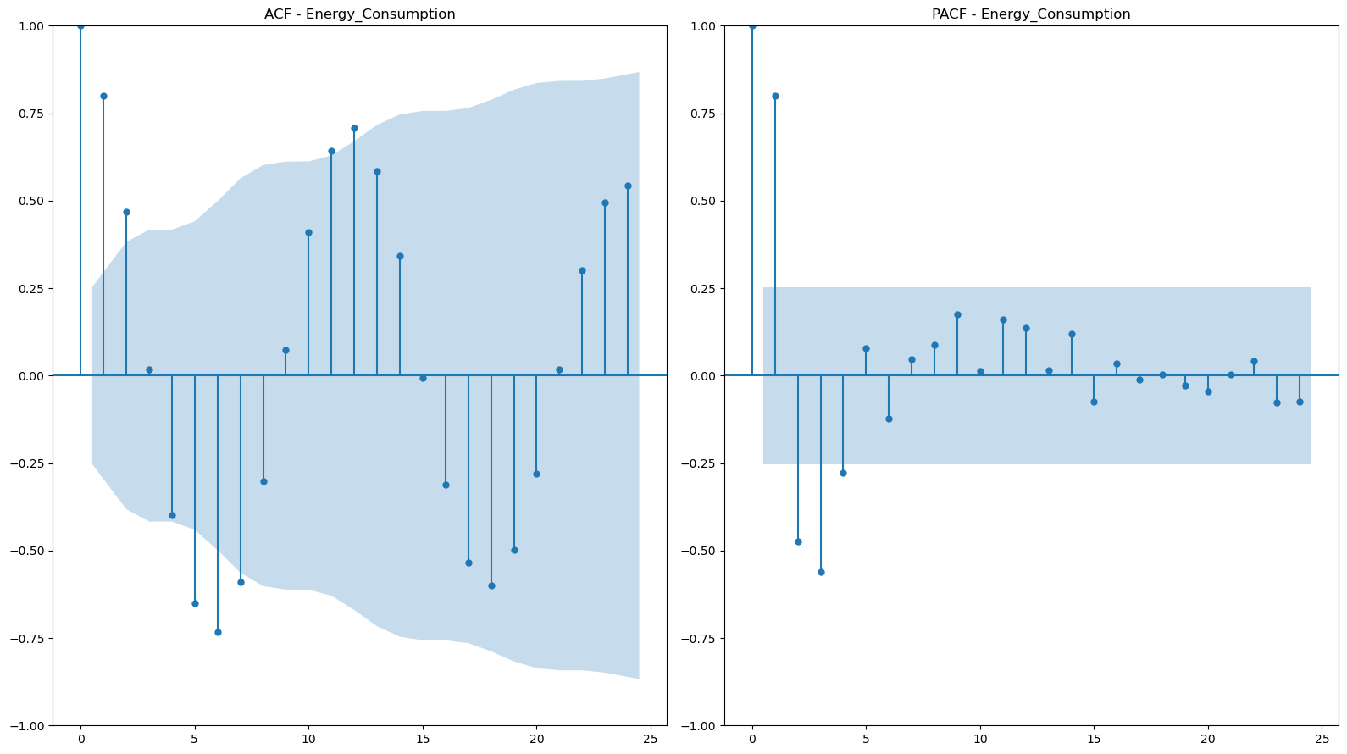
Figure 5: ACF and PACF Plot of Energy Consumption
Decomposition Plot:
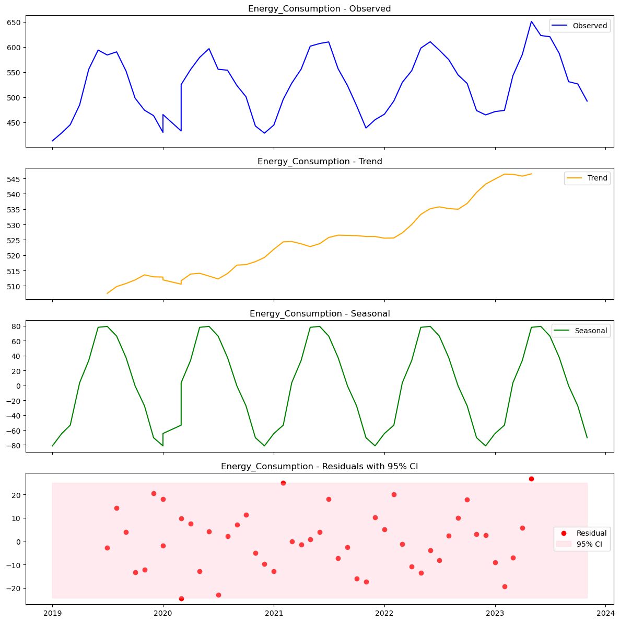
Figure 6: Decomposition plot of Energy Consumption
Comment on Decomposition Plot: The decomposition of Energy Consumption (2019–2023) highlights a seasonality-dominant structure:
- Trend: A gradual, non-linear increase with visible flattening around 2020 (likely pandemic-related).
- Seasonality: The dominant component. A massive, regular cycle (m = 12) with an amplitude (± 80 GWh) significantly larger than the trend growth.
- Residuals: Largely stationary noise centered around zero, though minor outliers appear.

Stock Price Index:
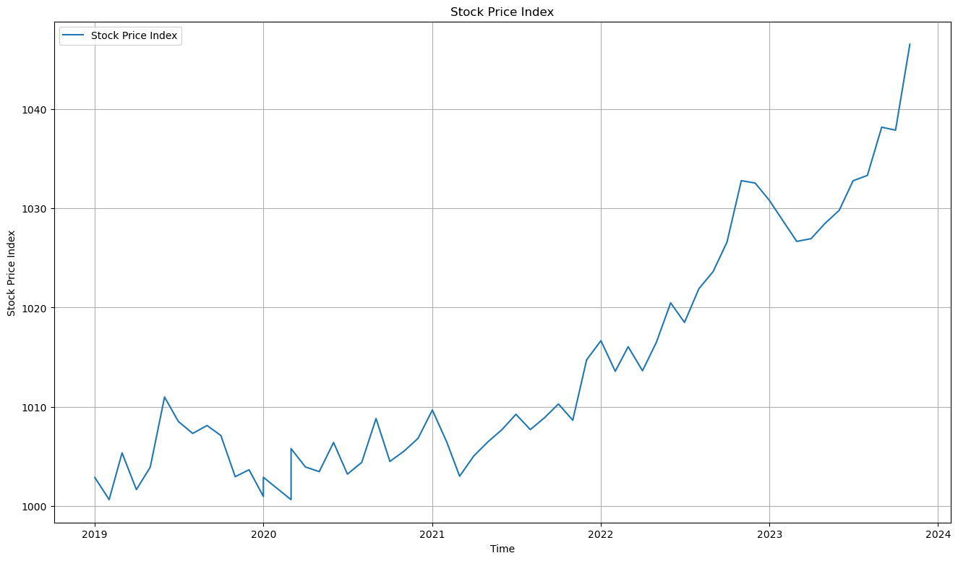
Figure 7: Plot of Stock Price Index vs Time
Description of pattern of Stock Price Index plot: Stock Price Index shows a parabolic upward trend. Seasonality is present visually but there is no clear pattern, cyclic behavior is not apparent from the plot, also this plot shows irregularity.
Statistic | Stock Price Index
Count | 60
Mean | 1,013.85
Median | 1,008.73
Std. Dev. | 11.72
Min | 1,000.63
Max | 1,046.54
Table 3: Descriptive Plot of Stock Price Index
In contrast to the other variables, the Stock Price Index is highly stable. The coefficient of variation (Standard Deviation divided by Mean) is approximately 1.1%, the lowest among all datasets. The tight trading range (1,000.63 – 1,046.54) implies a period of market consolidation or low volatility, which may impact the ability of forecasting models to detect strong directional trends.
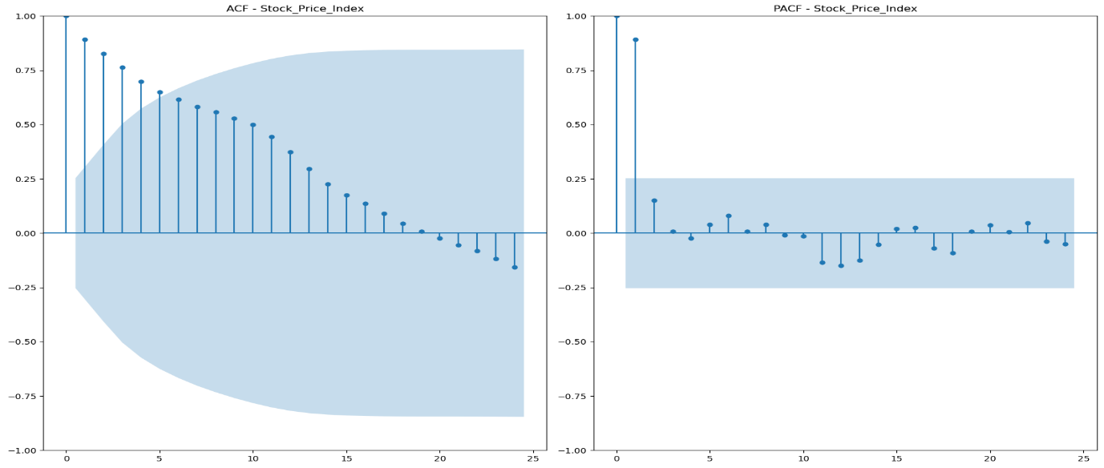
ACF and PACF Plot:
Figure 8: ACF and PACF Plot of Stock Price Index
Decomposition Plot:
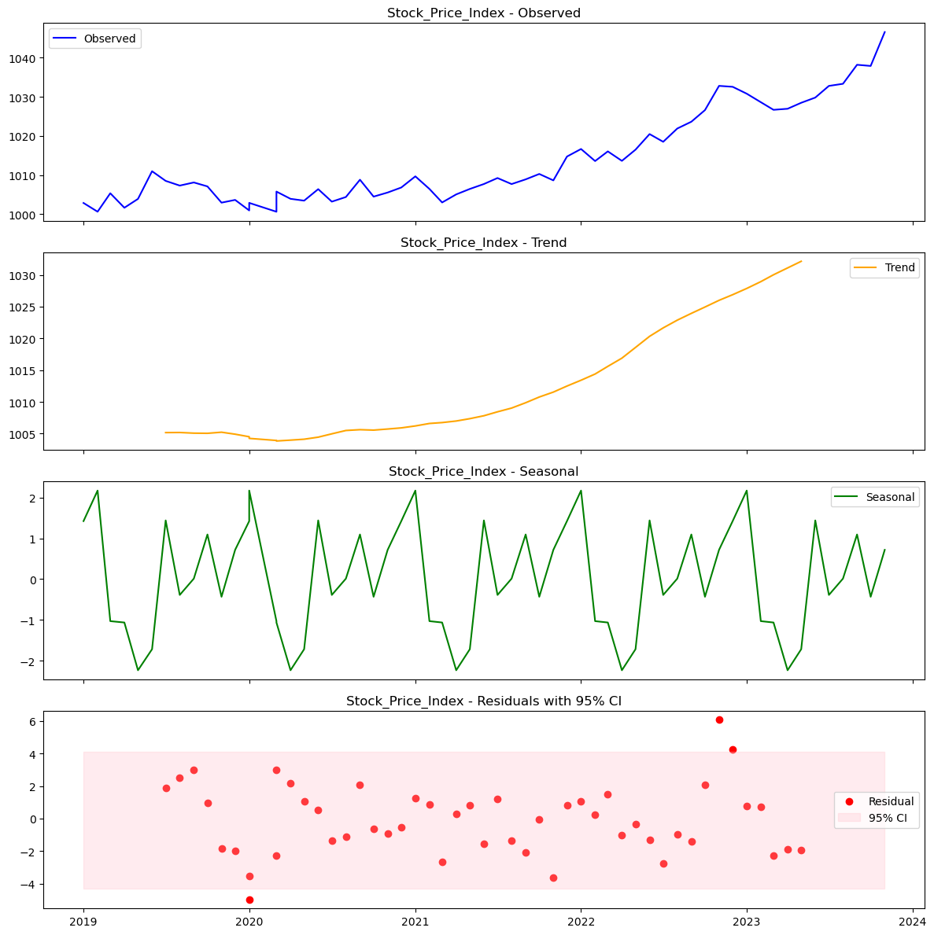
Figure 9: Decomposition Plot of Stock Price Index
Comment on Decomposition Plot: The decomposition of the Stock Price Index (2019–2023) reveals a structure almost entirely dominated by its long-term trajectory:
- Trend: The defining characteristic of the series is a robust, non-linear upward trajectory. The index exhibits accelerating growth, particularly steepening after 2021, indicating a strong bull market phase rather than a stable linear progression.
- Seasonality: A seasonal pattern is present but mathematically negligible. The amplitude of the cycle is approximately ±2 points, which is insignificant (<0.2%) relative to the index value (trading >1000). This suggests the market is driven by macro-trends rather than calendar cycles.
- Residuals: The residuals are mostly stationary and centered around zero, though a distinct widening of the variance (heteroscedasticity) is observed in the 2022–2023 period, reflecting increased market volatility in the later years.

Unemployment Rate Over Time:
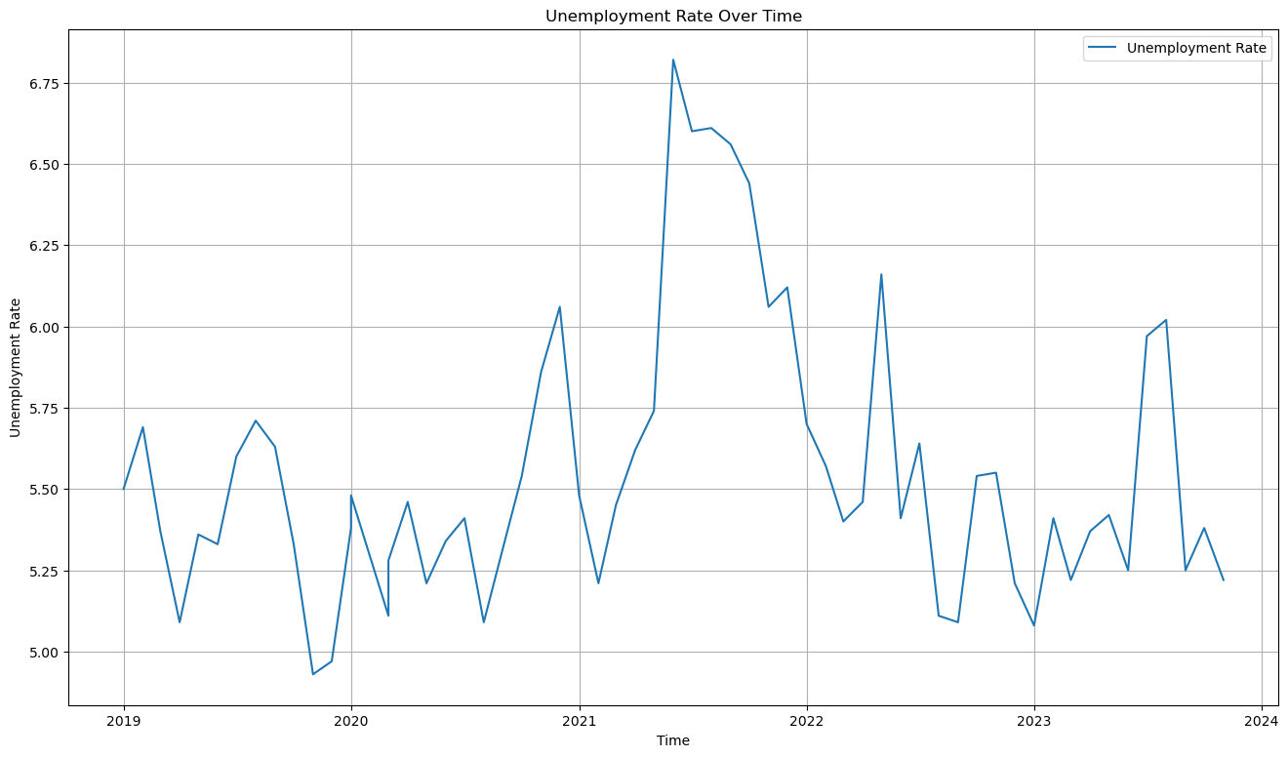
Figure 10: Plot of Unemployment Rate vs time
Description of pattern of Unemployment Rate over time plot: Unemployment Rate shows a non-linear trend. Seasonality is present, cyclic behavior is also apparent, also this plot shows irregularity.
Statistic | Unemployment Rate (%)
Count | 60
Mean | 5.55
Median | 5.44
Std. Dev. | 0.43
Min | 4.93
Max | 6.82
Table 4: Descriptive Statistics of Employment Rate
Unemployment Rate: The unemployment rate averaged 5.55% with a standard deviation of 0.43%. While the statistical variance is low, the economic significance of the range (4.93% to 6.82%) is meaningful. The distribution is slightly right-skewed (Mean > Median), suggesting that while the rate is generally stable, there are occasional spikes in unemployment.
ACF and PACF Plot:
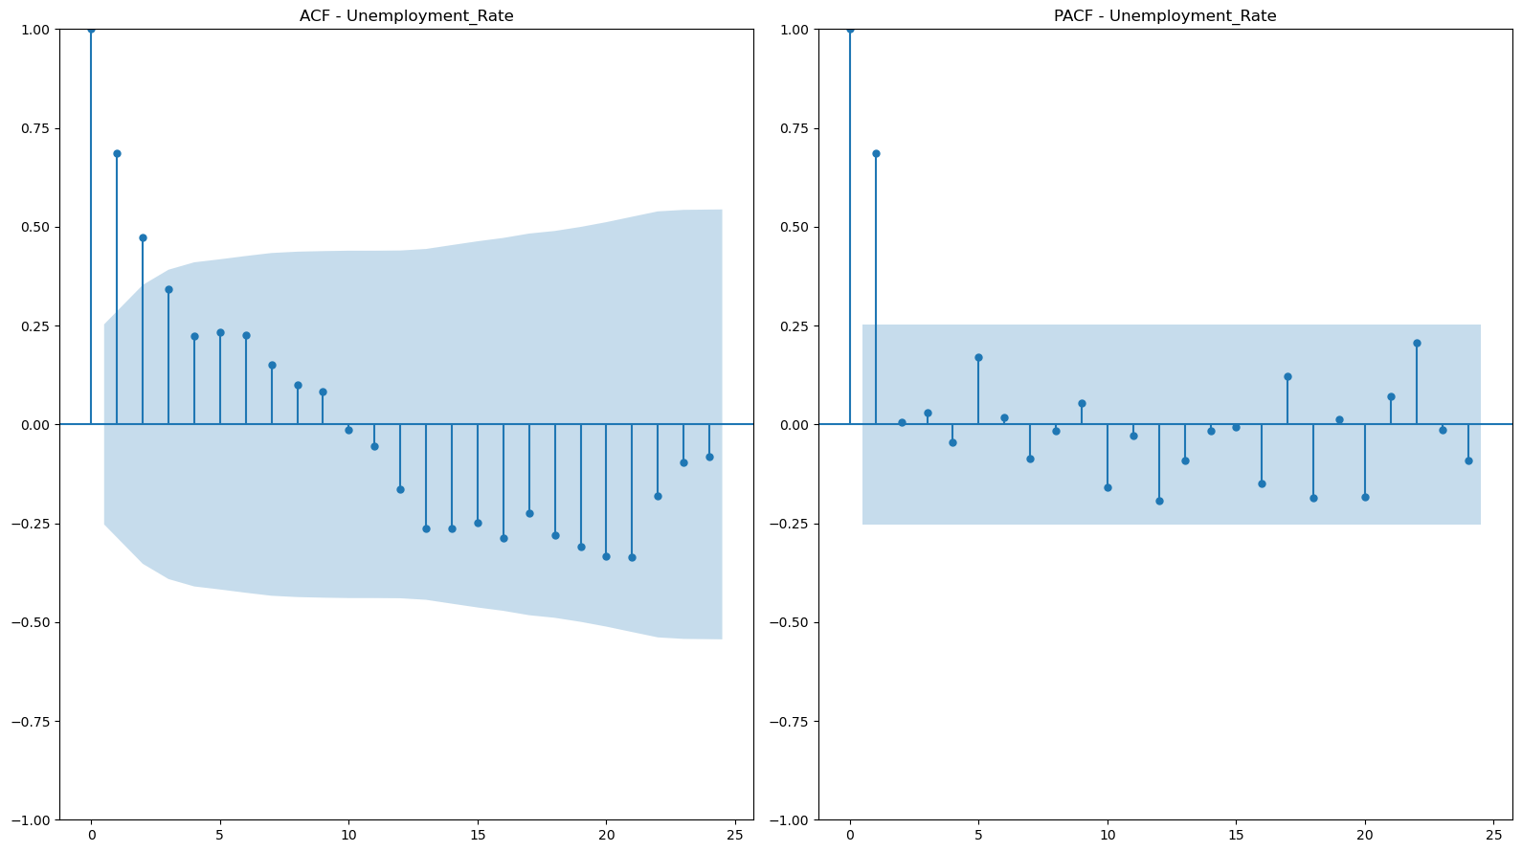
Figure 11: ACF and PACF Plot of Unemployment Rate
Decomposition Plot:
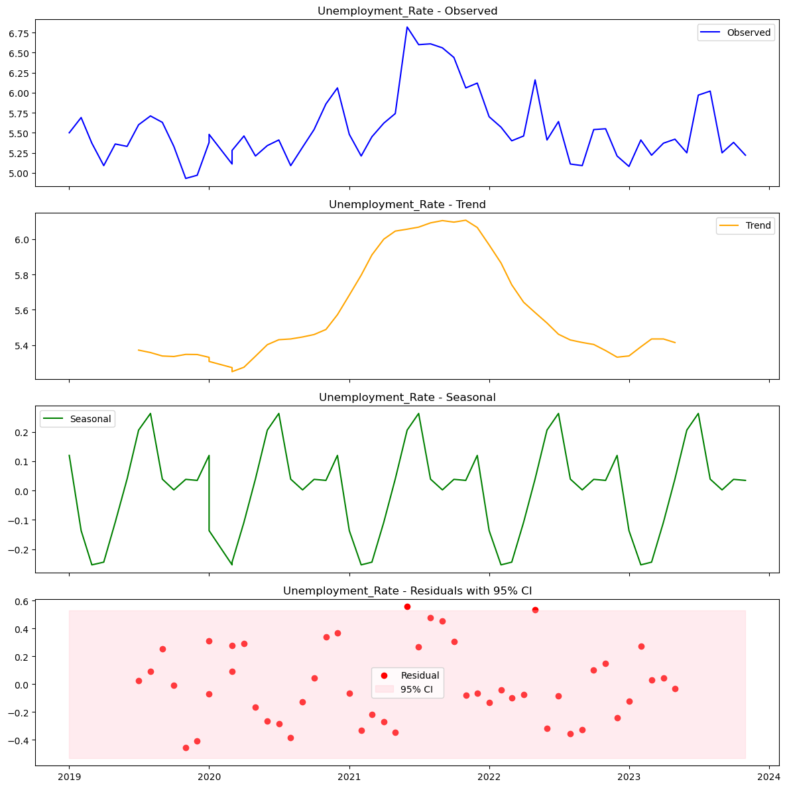
Figure 12: Decomposition Plot of Unemployment Rate
Comment on Decomposition Plot: The decomposition of the Unemployment Rate (2019–2023) reveals a structure heavily influenced by a specific special event:
- Trend: The dominant feature is a distinct, non-linear "hump." The trend rises sharply in 2020, peaks in early 2021, and gradually recovers (declines) through 2023. This indicates a structural shock rather than a consistent long-term growth pattern.
- Seasonality: A clear, repetitive additive cycle (m = 12) is present with an amplitude of roughly ± 0.25 %. While regular, this seasonal variation is secondary to the massive trend shifts.
- Residuals: The residuals are largely stationary and centered around zero, though there is some clustering of variance during the 2020–2021 volatility period.
In summary: Visual analysis confirms that none of the four series are stationary, as all exhibit non-constant means driven by trends. Energy Consumption and Retail Sales show clear, strong seasonality, whereas the Stock Price Index and Unemployment Rate display negligible seasonal patterns dominated by their respective trends.

Part-2: Unit Root Testing

Retail Sales

Retail Sales Original series (d=0)

Augmented Dickey Fuller Test for Retail Sales (original)
Test Result from EViews are below:
Null Hypothesis: RETAIL_SALES has a unit root
Exogenous: Constant, Linear Trend
Lag Length: 10 (Automatic - based on AIC, maxlag=10)
 |  |  | t-Statistic | Prob.*
Augmented Dickey-Fuller test statistic |  |  | -2.882642 | 0.1769
Table 5: ADF Test Results of Retail Sales (Level)
Key Takeaway: The null hypothesis from Augmented Dickey Fuller test is that the Retail Sales is not stationary series or has a unit root or $φ=1$ in the following model.
$${Retail_sales}_{t}=φ*{Retail_sales}_{t-1}+ ϵ_{t}$$
Alternate Hypothesis is: the Retail Sales is stationary or does not have a unit root.
Based on Akaike Information Criteria (AIC), the probability is 0.1769. So, we fail to reject the null hypothesis at 5% level of significance. So, the Retail sales series is not stationary.

Kwiatkowski-Phillips-Schmidt-Shin for Retail Sales (original)
Test Result from EViews are below:
Null Hypothesis: RETAIL_SALES is stationary
Exogenous: Constant, Linear Trend
Bandwidth: 4 (Newey-West automatic) using Bartlett kernel
 |  |  |  | LM-Stat.
Kwiatkowski-Phillips-Schmidt-Shin test statistic |  |  |  | 0.040038
Table 6: KPSS Test Results of Retail Sales (Level)
Key Takeaway: The null hypothesis from Kwiatkowski-Phillips-Schmidt-Shin (KPSS) is that the Retail Sales is a stationary series.
Alternate Hypothesis is: the Retail Sales is not stationary.
Based on using Bartlett kernel, the test statistics (Lagrange Multiplier Statistic) is 0.040038, whereas at 5% level of significance LM Statistic is 0.146000 which is higher than the test statistics. So, we fail to reject the null hypothesis at 5% level of significance. So, the Retail sales is stationary.
So, ADF indicates not-stationary whereas KPSS test indicates that the Retail Sales (original series) is stationary. Test statistics for both test is marginal, or may not capture the features.

Retail Sales with First Differencing (d=1)

Augmented Dickey Fuller Test for Retail Sales (First Differenced)
Test Result from EViews are below:
Null Hypothesis: D(RETAIL_SALES) has a unit root
Exogenous: Constant, Linear Trend
Lag Length: 9 (Automatic - based on AIC, maxlag=10)
 |  |  | t-Statistic | Prob.*
Augmented Dickey-Fuller test statistic |  |  | -7.531274 | 0.0000
Table 7: ADF Test Result of Retail Sales (First Differencing)
Key Takeaway: The null hypothesis from Augmented Dickey Fuller test is that the First Differenced Retail Sales is not stationary series or has a unit root or $φ=1$ in the following model.
$$D({Retail_sales)}_{t}=φ*D{(Retail_sales)}_{t-1}+ ϵ_{t}$$
Alternate Hypothesis is: the First Differenced Retail Sales is stationary or does not have a unit root.
Based on Akaike Information Criteria (AIC), the probability is 0.1769. So, we reject the null hypothesis at 5% level of significance. So, the First Differenced Retail sales is stationary.

Kwiatkowski-Phillips-Schmidt-Shin for Retail Sales (First Differenced)
Test Result from EViews are below:
Null Hypothesis: D(RETAIL_SALES) is stationary
Exogenous: Constant, Linear Trend
Bandwidth: 3 (Newey-West automatic) using Bartlett kernel
 |  |  |  | LM-Stat.
Kwiatkowski-Phillips-Schmidt-Shin test statistic |  |  |  | 0.024714
Table 8: KPSS Test Result of Retail Sales (First Differencing)
Key Takeaway: The null hypothesis from Kwiatkowski-Phillips-Schmidt-Shin (KPSS) is that the First Differenced Retail Sales is a stationary series.
Alternate Hypothesis is: the First Differenced Retail Sales is not stationary.
Based on using Bartlett kernel, the test statistics (Lagrange Multiplier Statistic) is 0.024714, whereas at 5% level of significance LM Statistic is 0.146000 which is higher than the test statistics. So, we fail to reject the null hypothesis at 5% level of significance. So, the Retail sales is stationary.
So, both ADF and KPSS test indicates that the Retail Sales (First Differenced) is stationary.

Energy Consumption:

Energy Consumption (Original)

Augmented Dickey Fuller Test for Energy Consumption (original):
Test Result from EViews are below:
Null Hypothesis: ENERGY_CONSUMPTION has a unit root
Exogenous: Constant, Linear Trend
Lag Length: 7 (Automatic - based on AIC, maxlag=10)
 |  |  | t-Statistic | Prob.*
Augmented Dickey-Fuller test statistic |  |  | -5.831688 | 0.0001
Table 9: ADF Test Result of Energy Consumption (Level)
Key Takeaway: The null hypothesis from Augmented Dickey Fuller test is that the Energy Consumption is not stationary series or has a unit root or $φ=1$ in the following model.
$${Energy_Consumption}_{t}=φ*{Energy_Consumption}_{t-1}+ ϵ_{t}$$
Alternate Hypothesis is: the Energy Consumption is stationary or does not have a unit root.
Based on Akaike Information Criteria (AIC), the probability is 0. 0001. So, we reject the null hypothesis at 5% level of significance. So, the Energy Consumption series is stationary.

Kwiatkowski-Phillips-Schmidt-Shin test For Energy Consumption (original):
Test Result from EViews are below:
Null Hypothesis: ENERGY_CONSUMPTION is stationary
Exogenous: Constant, Linear Trend
Bandwidth: 4 (Newey-West automatic) using Bartlett kernel
 |  |  |  | LM-Stat.
Kwiatkowski-Phillips-Schmidt-Shin test statistic |  |  |  | 0.025415
Table 10: KPSS Test Result of Energy Consumption (Level)
Key Takeaway: The null hypothesis from Kwiatkowski-Phillips-Schmidt-Shin (KPSS) is that the Energy Consumption is trend-stationary.
Alternate Hypothesis is: the Energy Consumption is not trend-stationary.
Based on using Bartlett kernel, the test statistics (Lagrange Multiplier Statistic) is 0.025415, whereas at 5% level of significance LM Statistic is 0.146000 which is higher than the test statistics. So, we fail to reject the null hypothesis at 5% level of significance. So, the Energy Consumption is stationary.
So, ADF and KPSS test indicates that the Energy Consumption is stationary.

Energy Consumption (First Differenced)

Augmented Dickey Fuller Test for Energy Consumption (First Differenced):
Test Result from EViews are below:
Null Hypothesis: D(ENERGY_CONSUMPTION) has a unit root
Exogenous: Constant, Linear Trend
Lag Length: 9 (Automatic - based on AIC, maxlag=10)
 |  |  | t-Statistic | Prob.*
Augmented Dickey-Fuller test statistic |  |  | -6.448077 | 0.0000
Table 11: ADF Test Result of Energy Consumption (First Differencing)
Key Takeaway: The null hypothesis from Augmented Dickey Fuller test is that the first differenced Energy Consumption is not stationary series or has a unit root or $φ=1$ in the following model.
$${D(Energy_Consumption)}_{t}=φ*{D(Energy_Consumption)}_{t-1}+ ϵ_{t}$$
Alternate Hypothesis is: the first differenced Energy Consumption is stationary or does not have a unit root.
Based on Akaike Information Criteria (AIC), the probability is 0. 0000. So, we reject the null hypothesis at 5% level of significance. So, the First Differenced Energy Consumption series is stationary.

Kwiatkowski-Phillips-Schmidt-Shin test For Energy Consumption (First Differenced):
Test Result from EViews are below:
Null Hypothesis: D(ENERGY_CONSUMPTION) is stationary
Exogenous: Constant, Linear Trend
Bandwidth: 4 (Newey-West automatic) using Bartlett kernel
 |  |  |  | LM-Stat.
Kwiatkowski-Phillips-Schmidt-Shin test statistic |  |  |  | 0.031773
Table 12: KPSS Test Result of Energy Consumption (First Differencing)
Key Takeaway: The null hypothesis from Kwiatkowski-Phillips-Schmidt-Shin (KPSS) is that the first differenced Energy Consumption is trend-stationary.
Alternate Hypothesis is: the first differenced Energy Consumption is not trend-stationary.
Based on using Bartlett kernel, the test statistics (Lagrange Multiplier Statistic) is 0.031773, whereas at 5% level of significance LM Statistic is 0.146000 which is higher than the test statistics. So, we fail to reject the null hypothesis at 5% level of significance. So, the first differenced Energy Consumption is stationary.
So, ADF and KPSS test indicates that the Energy Consumption (First Differenced) is stationary.

Stock Price Index

Stock Price Index (Original)

Augmented Dickey Fuller Test for Stock Price Index (Original):
Test Result from EViews are below:
Null Hypothesis: STOCK_PRICE_INDEX has a unit root
Exogenous: Constant, Linear Trend
Lag Length: 1 (Automatic - based on AIC, maxlag=10)
 |  |  | t-Statistic | Prob.*
Augmented Dickey-Fuller test statistic |  |  | -0.614320 | 0.9743
Table 13: ADF Test Result of Stock Price Index (Level)
Key Takeaway: The null hypothesis from Augmented Dickey Fuller test is that the Stock Price Index is not stationary series or has a unit root or $φ=1$ in the following model.
$${Stock_Price_Index}_{t}=φ*{Stock_Price_Index}_{t-1}+ ϵ_{t}$$
Alternate Hypothesis is: the Stock Price Index is stationary or does not have a unit root.
Based on Akaike Information Criteria (AIC), the probability is 0.9743. So, we fail to reject the null hypothesis at 5% level of significance. So, the Stock Price Index series is not stationary.

Kwiatkowski-Phillips-Schmidt-Shin test For Stock Price Index (Original):
Test Result from EViews are below:
Null Hypothesis: STOCK_PRICE_INDEX is stationary
Exogenous: Constant, Linear Trend
Bandwidth: 5 (Newey-West automatic) using Bartlett kernel
 |  |  |  | LM-Stat.
Kwiatkowski-Phillips-Schmidt-Shin test statistic |  |  |  | 0.261660
Table 14: ADF Test Result of Stock Price Index (Level)
Key Takeaway: The null hypothesis from Kwiatkowski-Phillips-Schmidt-Shin (KPSS) is that the Stock Price Index is trend-stationary.
Alternate Hypothesis is: the Stock Price Index is not trend-stationary.
Based on using Bartlett kernel, the test statistics (Lagrange Multiplier Statistic) is 0.261660, whereas at 5% level of significance LM Statistic is 0.146000 which is lower than the test statistics. So, we reject the null hypothesis at 5% level of significance. So, the Stock Price Index is not trend-stationary.
So, both ADF and KPSS test indicates that the Stock Price Index is not stationary.

Stock Price Index (First Differenced)

Augmented Dickey Fuller Test for Stock Price Index (First Differenced):
Test Result from EViews are below:
Null Hypothesis: D(STOCK_PRICE_INDEX) has a unit root
Exogenous: Constant, Linear Trend
Lag Length: 1 (Automatic – based on AIC, maxlag=10)
 |  |  | t-Statistic | Prob.*
Augmented Dickey-Fuller test statistic |  |  | -9.390958 | 0.0000
Table 15: ADF Test Result of Stock Price Index (First Differenced)
Key Takeaway: The null hypothesis from Augmented Dickey Fuller test is that the Stock Price Index is not stationary series or has a unit root or $φ=1$ in the following model.
$$D({Stock_Price_Index)}_{t}=φ*{D(Stock_Price_Index)}_{t-1}+ ϵ_{t}$$
Alternate Hypothesis is: the Stock Price Index is stationary or does not have a unit root.
Based on Akaike Information Criteria (AIC), the probability is 0.0000. So, we reject the null hypothesis at 5% level of significance. So, the first differenced Stock Price Index series is stationary.

Kwiatkowski-Phillips-Schmidt-Shin test For Stock Price Index (First Differenced):
Test Result from EViews are below:

Null Hypothesis: D(STOCK_PRICE_INDEX) is stationary
Exogenous: Constant, Linear Trend
Bandwidth: 2 (Newey-West automatic) using Bartlett kernel
 |  |  |  | LM-Stat.
Kwiatkowski-Phillips-Schmidt-Shin test statistic |  |  |  | 0.050163
Table 16: ADF Test Result of Stock Price Index (First Differenced)
Key Takeaway: The null hypothesis from Kwiatkowski-Phillips-Schmidt-Shin (KPSS) is that the Stock Price Index is trend-stationary.
Alternate Hypothesis is: the Stock Price Index is not trend-stationary.
Based on using Bartlett kernel, the test statistics (Lagrange Multiplier Statistic) is 0.050163, whereas at 5% level of significance LM Statistic is 0.146000 which is higher than the test statistics. So, we fail to reject the null hypothesis at 5% level of significance. So, the Stock Price Index with First Differenced is trend-stationary.
So, both ADF and KPSS test indicates that the First Differenced Stock Price Index is stationary.

Unemployment Rate

Unemployment Rate (Original)

Augmented Dickey Fuller Test for Unemployment Rate (Original):
Test Result from EViews are below:
Null Hypothesis: UNEMPLOYMENT_RATE has a unit root
Exogenous: Constant, Linear Trend
Lag Length: 1 (Automatic – based on AIC, maxlag=10)
 |  |  | t-Statistic | Prob.*
Augmented Dickey-Fuller test statistic |  |  | -3.141691 | 0.1065
Table 17: ADF Test Result of Unemployment Rate (Level)
Key Takeaway: The null hypothesis from Augmented Dickey Fuller test is that the Unemployment Rate is not stationary series or has a unit root or $φ=1$ in the following model.
$${Unemployment_Rate}_{t}=φ*{Unemployment_Rate}_{t-1}+ ϵ_{t}$$
Alternate Hypothesis is: the Unemployment Rate is stationary or does not have a unit root.
Based on Akaike Information Criteria (AIC), the probability is 0.1065. So, we fail to reject the null hypothesis at 5% level of significance. So, the Unemployment Rate series is not stationary.

Kwiatkowski-Phillips-Schmidt-Shin test For Unemployment Rate (Original):
Test Result from Eviews are below:
Null Hypothesis: UNEMPLOYMENT_RATE is stationary
Exogenous: Constant, Linear Trend
Bandwidth: 5 (Newey-West automatic) using Bartlett kernel
 |  |  |  | LM-Stat.
Kwiatkowski-Phillips-Schmidt-Shin test statistic |  |  |  | 0.144160
Table 18: KPSS Test Result of Unemployment Rate (Level)
Key Takeaway: The null hypothesis from Kwiatkowski-Phillips-Schmidt-Shin (KPSS) is that the Unemployment Rate is trend-stationary.
Alternate Hypothesis is: the Unemployment Rate is not trend-stationary.
Based on using Bartlett kernel, the test statistics (Lagrange Multiplier Statistic) is 0.144160, whereas at 5% level of significance LM Statistic is 0.146000 which is higher than the test statistics. So, we fail to reject the null hypothesis at 5% level of significance. So, the Unemployment Rate is trend-stationary.
So, ADF test indicates the trend is not stationary and KPSS test indicates that the Unemployment Rate is stationary or more precisely trend-stationary.

Unemployment Rate (First Differenced)

Augmented Dickey Fuller Test for Unemployment Rate (First Differenced):
Test Result from EViews are below:
Null Hypothesis: D(UNEMPLOYMENT_RATE) has a unit root
Exogenous: Constant, Linear Trend
Lag Length: 1 (Automatic – based on AIC, maxlag=10)
 |  |  | t-Statistic | Prob.*
Augmented Dickey-Fuller test statistic |  |  | -8.679647 | 0.0000
Table 19: ADF Test Result of Unemployment Rate (First Differenced)
Key Takeaway: The null hypothesis from Augmented Dickey Fuller test is that the Unemployment Rate is not stationary series or has a unit root or $φ=1$ in the following model.
$$D({Unemployment_Rate) }_{t}=φ*{D(Unemployment Rate)}_{t-1}+ ϵ_{t}$$
Alternate Hypothesis is: the Unemployment Rate is stationary or does not have a unit root.
Based on Akaike Information Criteria (AIC), the probability is 0.0000. So, we reject the null hypothesis at 5% level of significance. So, the first differenced Unemployment Rate series is stationary.

Kwiatkowski-Phillips-Schmidt-Shin test For Unemployment Rate (First Differenced):
Test Result from Eviews are below:
Null Hypothesis: D(UNEMPLOYMENT_RATE) is stationary
Exogenous: Constant, Linear Trend
Bandwidth: 6 (Newey-West automatic) using Bartlett kernel
 |  |  |  | LM-Stat.
Kwiatkowski-Phillips-Schmidt-Shin test statistic |  |  |  | 0.066809
Table 20: KPSS Test Result of Unemployment Rate (First Differenced)
Key Takeaway: The null hypothesis from Kwiatkowski-Phillips-Schmidt-Shin (KPSS) is that the Unemployment Rate is trend-stationary.
Alternate Hypothesis is: the Unemployment Rate is not trend-stationary.
Based on using Bartlett kernel, the test statistics (Lagrange Multiplier Statistic) is 0.066809, whereas at 5% level of significance LM Statistic is 0.146000 which is higher than the test statistics. So, we fail to reject the null hypothesis at 5% level of significance. So, the Unemployment Rate with First Differenced is trend-stationary.
So, both ADF and KPSS test indicates that the First Differenced Unemployment Rate is stationary.

Summary Table of the Unit Root Test
Time Series | Transformation | ADF Test (H0​: Unit Root) | KPSS Test (H0​: Stationary) | Conclusion
Retail Sales | Level (Original) | Fail to Reject | Fail to Reject | Conflicting (Likely Trend Stationary)
Retail Sales | First Difference | Reject | Fail to Reject | Stationary
Energy Cons. | Level (Original) | Reject | Fail to Reject | Stationary (Trend Stationary)
Energy Cons. | First Difference | Reject | Fail to Reject | Stationary
Stock Price | Level (Original) | Fail to Reject | Reject | Not Stationary
Stock Price | First Difference | Reject | Fail to Reject | Stationary
Unemployment | Level (Original) | Fail to Reject | Fail to Reject | Conflicting (Likely Trend Stationary)
Unemployment | First Difference | Reject | Fail to Reject | Stationary
Table 21: Summary Table of Unit Root Test of all series

Conclusion on Unit Root Test:
The ADF and KPSS tests do not agree for all series, which is expected because the two tests have opposite null hypotheses. For Retail Sales and Unemployment Rate, the ADF test fails to reject the presence of a unit root while the KPSS test fails to reject trend-stationarity, producing mixed conclusions. These disagreements normally not common but the test statistics conclusion is very marginal. Literature review explains that this type of situation arise when a series contains strong deterministic trends, structural shifts, or pronounced seasonality that is not fully captured in the test specification.

Part 3: ARIMA Modeling

ARIMA Modeling on Retail Sales
Retail sales -trend and seasonality and Energy Consumption – strong seasonality
Retail sales will become stationary with d = 1, for parameter for I is 1. The ACF and PACF curve for d = 1 is down below:
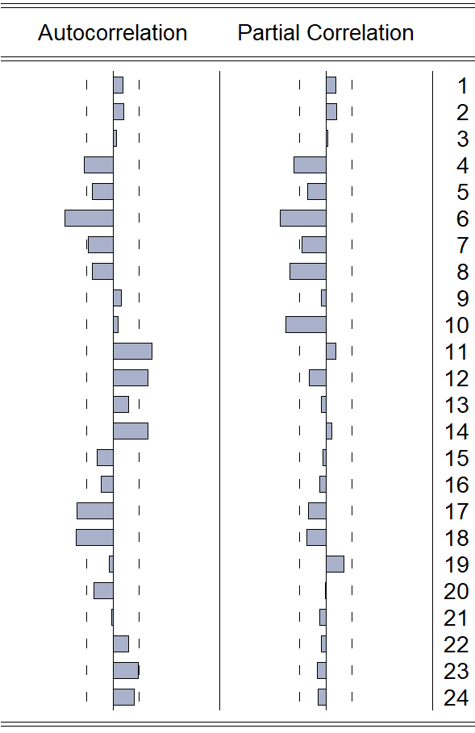
Figure 13: ACF and PACF Plot of Retail Sales at d = 1
Here, lower lag at which the ACF value beyond the CI or q = [4, 6] on the other hand For PACF, or p = [4, 6, 8 10]. So, candidate ARIMA is ARIMA (p, 1, q).
Applying different combinations, we get the following AIC values:
Model  AIC | ARIMA  (10,1,6) | ARIMA  (8,1,6) | ARIMA  (10,1,4) | ARIMA  (8,1,4) | ARIMA  (6,1,6) | ARIMA  (6,1,4) | ARIMA  (4,1,6) | ARIMA  (4,1,4)
 | 6.44 | 6.746 | 6.92 | 6.74 | 6.42 | 6.74 | 7.2244 | 6.66
Table 22: ARIMA models comparison
So ARIMA(6,1,6) is the best model in this scenario.
Here MA terms are not significant for the 5% level of significance. But from PACF and ACF plot indicates the ARMA parameters, even though the all the parameters are not significant. As the from the indication and AIC criteria ARIMA (6,1,6) has been chosen as the best model. The diagnostic plots and tests are down below:
Residuals plot over time: | ACF Plot of Residuals
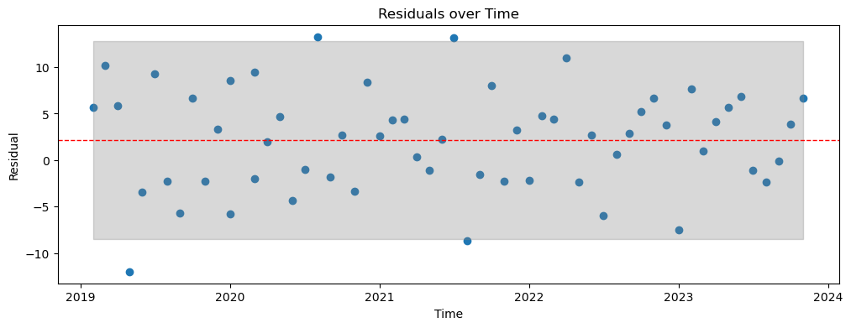 | 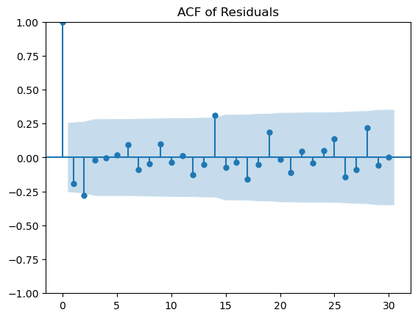
Figure 14: Diagnostic Plot of ARIMA (6,1,6) of Retail sales.
Ljung-Box Test of Residual:
Null Hypothesis (H₀): The data is independently distributed (random). There is no autocorrelation up to lag k=24.
Alternative Hypothesis (H_{A}): The data is not independently distributed. There is significant autocorrelation at some lags.
Ljung-Box test statistic: 26.52
p-value: 0.33
So, null hypothesis cannot be rejected at the 0.05% level of significance. Or in other words, the residual data is independently distributed (random). There is no autocorrelation up to lag k=24 in the residual.
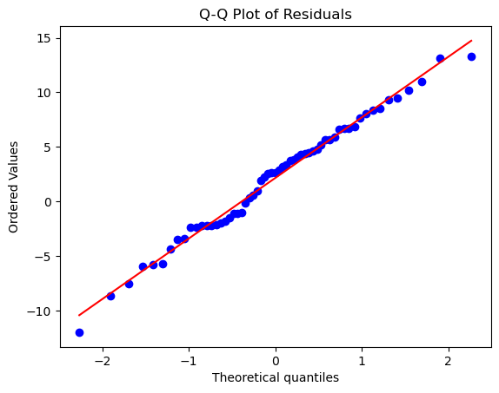
Figure 15: Q-Q Plot of Residual for Retail Sales
Null Hypothesis (H₀): The data is normally distributed.
Alternative Hypothesis (H_{A}): The data is NOT normally distributed.
Shapiro-Wilk test statistic: 0.99
p-value: 0.84
So, p-value indicates that we fail to reject the Null Hypothesis at 5% level of significance. So, the data is normally distributed. This is also confirmed from the QQ plot.
From the analysis it is apparent that, the residual almost behaves like the white noise as the mean is close to zero, variance is constant and from Ljung-Box test it is evident that for the 5% level of significance the residuals do not have autocorrelation.
The forecasting graph is down below:
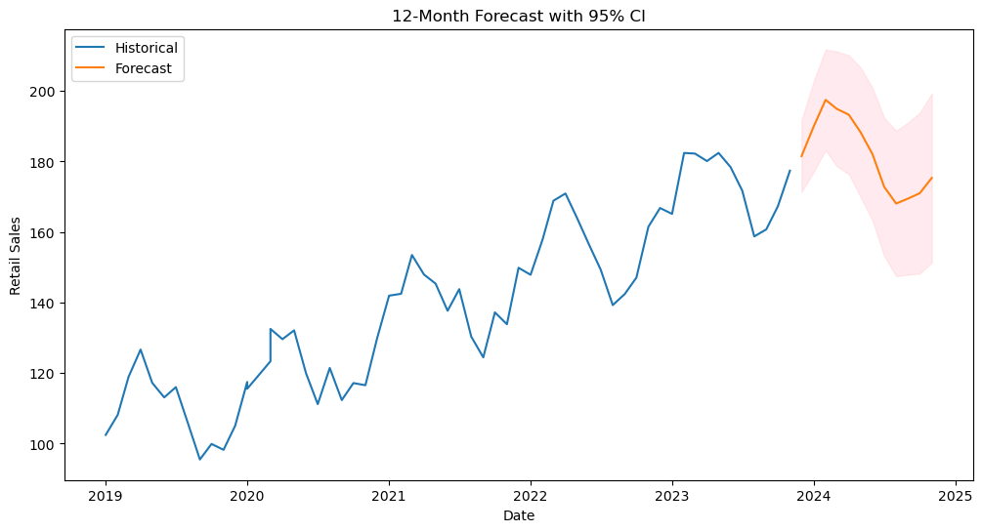
Figure 16: Forecasting with ARIMA (6,1,6)

ARIMA on Stock Price Index
Energy Consumption will become stationary with d = 1, for parameter for I is 1. The ACF and PACF curve for d = 1 is down below:
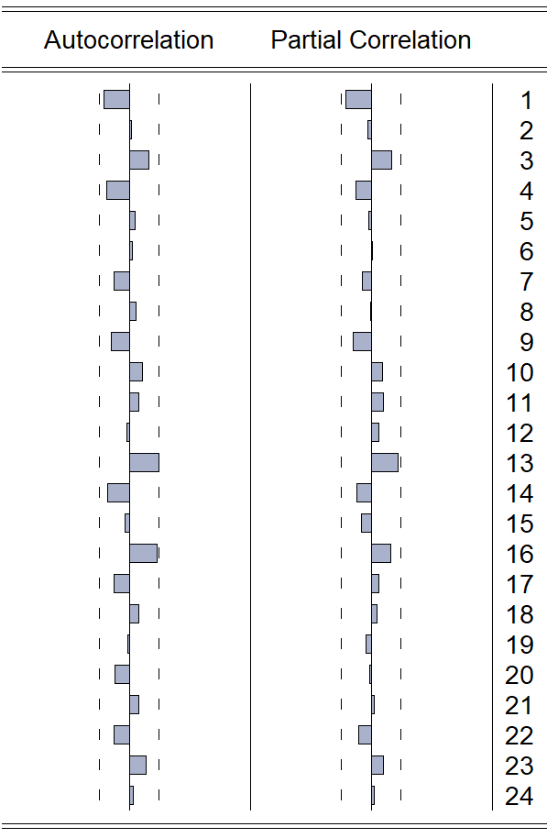
Figure 17: ACF and PACF Plot of Stock Price Index with d = 1
Here, lower lag at which the ACF value beyond the CI or q = [4, 6] on the other hand For PACF, or p = [4, 6, 8 10]. So, candidate ARIMA is ARIMA (p, 1, q).
Applying different combinations, we get the following AIC values:
Model  AIC | ARIMA  (1,1,1) | ARIMA  (1,1,0) | ARIMA  (0,1,1)
 | 5.154 | 5.120 | 5.124
Table 23: ARIMA models of Stock Price Index comparison with AIC
So ARIMA(1,1,0) is the best model in this scenario.
Here AR terms are not significant for the 5% level of significance but AIC criteria is lower in case of ARIMA (1,1,0). But from PACF and ACF plot indicates the ARMA parameters, even though the all the parameters are not significant. As the from the indication and AIC criteria ARIMA (1,1,0) has been chosen as the best model. The diagnostic plots and tests are down below:
Residuals plot over time: | ACF and PACF Plot of Residuals
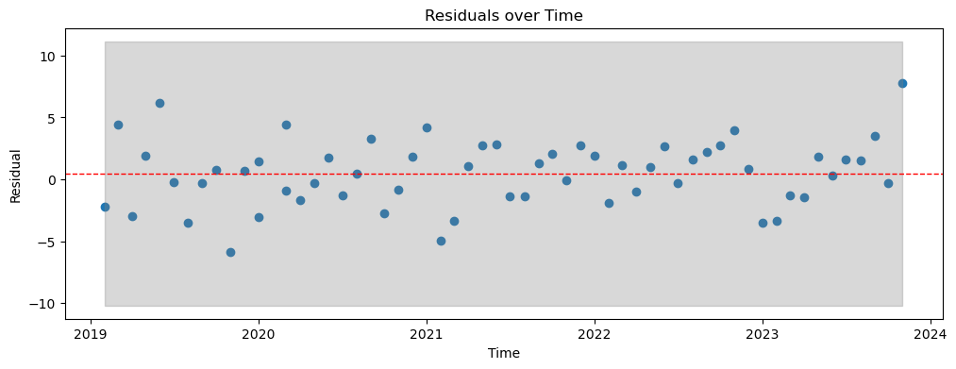 | 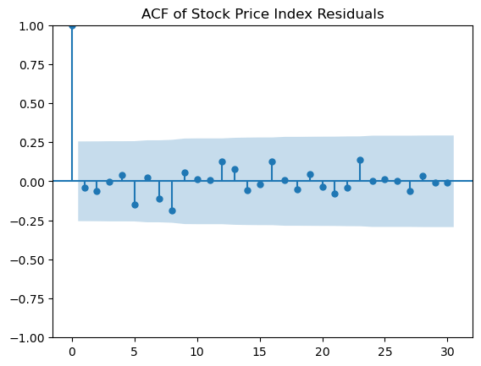
Figure 18: Diagnostic Plot of Stock Price Index ARIMA model (1,1,0)
Ljung-Box Test of Residual:
Null Hypothesis (H₀): The data is independently distributed (random). There is no autocorrelation up to lag k=24.
Alternative Hypothesis (H_{A}): The data is not independently distributed. There is significant autocorrelation at some lags.
Ljung-Box test statistic: 12.067
p-value: 0.979
So, null hypothesis cannot be rejected at the 0.05% level of significance. Or in other words, the residual data is independently distributed (random). There is no autocorrelation up to lag k=24 in the residual.
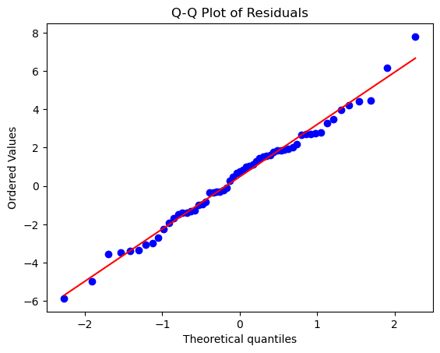
Figure 19: Q-Q Plot of Residual of ARIMA (1,1,0) of Stock Price Index
Null Hypothesis (H₀): The data is normally distributed.
Alternative Hypothesis (H_{A}): The data is NOT normally distributed.
Shapiro-Wilk test statistic: 0.991
p-value: 0.939
So, p-value indicates that we fail to reject the Null Hypothesis at 5% level of significance. So, the data is normally distributed. This is also confirmed from the QQ plot.
From the analysis it is apparent that, the residual almost behaves like the white noise as the mean is close to zero, variance is constant and from Ljung-Box test it is evident that for the 5% level of significance the residuals do not have autocorrelation.
The forecasting graph is down below:
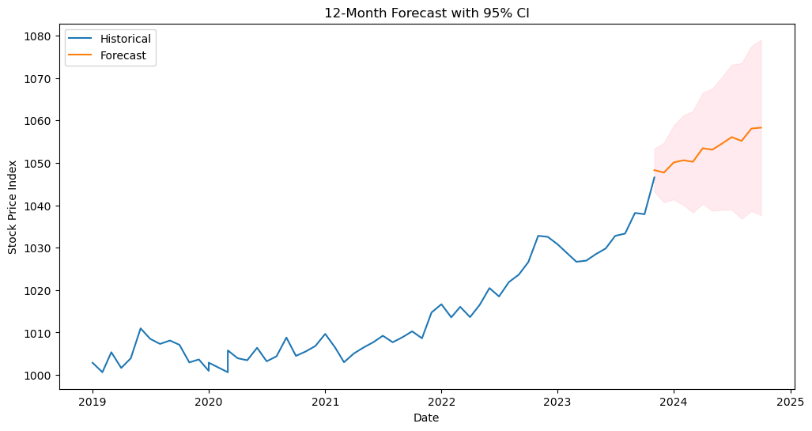
Figure 20: Forecasting withARIMA (1,1,0)

Part 4: SARIMA Modeling
From visual Inspection of the part 1 it is evident that the strongest seasonal pattern is Energy Consumption.
Justification of Choosing the Energy Consumption Series: This series likely exhibits a very clear, smooth, and repetitive "sinusoidal" (wave-like) pattern with distinct peaks (likely in summer/winter for heating/cooling) and valleys that happen at the exact same time every year. The Seasonal Component accounts for most of the total variation in Energy Consumption.
Seasonal Period: Looking at the dates of the data file (2019-01-01, 2019-02-01, etc.), the data is collected Monthly. For monthly data, the natural seasonal cycle is one year. So, S = 12.
ACF and PACF at seasonal lags:
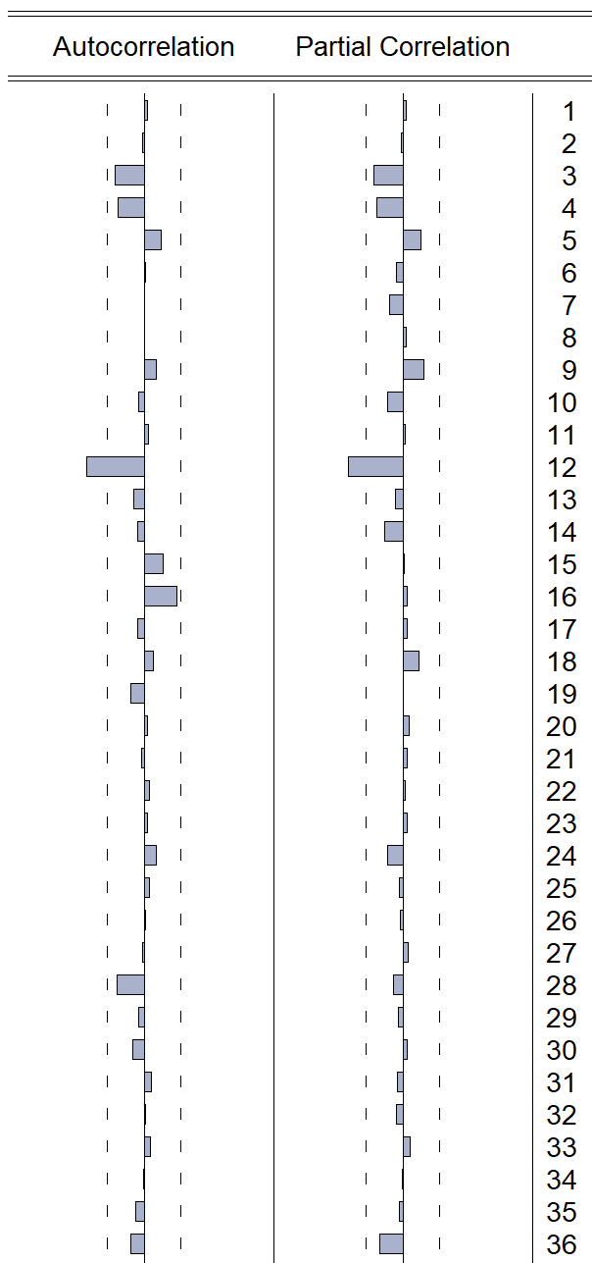
Figure 21: Seasonal Differenced (D=1) ACF and PACF Plot of Energy Consumption
From ACF and PACF of seasonal differencing (D = 1) it is clearly evident that P value from PACF is 1 and Q value from ACF is 1.
So, three SARIMA candidates are SARIMA (0,0,0) (1,1,1)₁₂ or SARIMA (0,0,0) (1,1,0)₁₂ or SARIMA (0,0,0) (0,1,1)₁₂.
Similar for ARIMA Analysis, it is found that ARIMA (2,1,3) is the best model by analyzing different combinations of p (0-6) and q (0-7) value and previously (part 2) found d = 1.
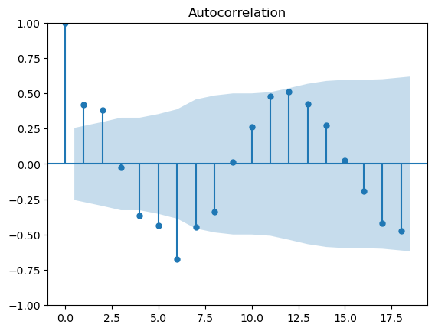 | 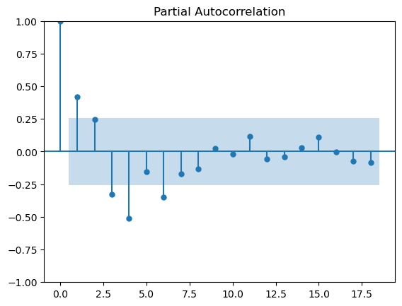
Figure 22: ACF and PACF of non-seasonal difference (d = 1) of Energy Consumption
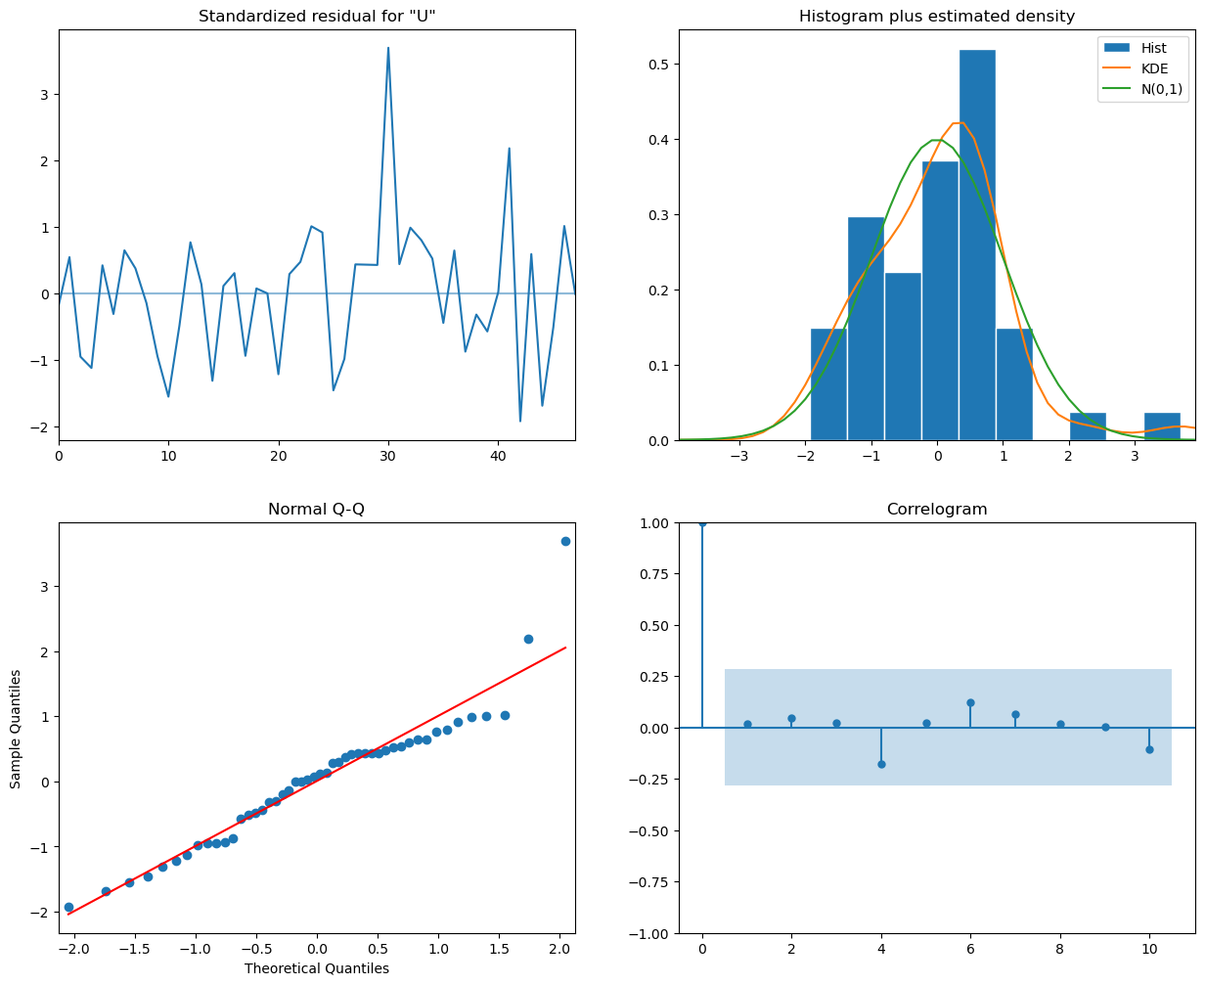
Figure 23: Diagnostic Plot of ARIMA (2,1,3) for Energy Consumption
So, the Residual is white noise.
Best ARIMA Model or ARIMA(2,1,3) and SARIMA models comparison is down blow:
S/N | Model | AIC | BIC | RMSE | Comment
1 | SARIMA (0, 0, 0)x(1, 1, 0, 12) | 5.500036 | 5.552820 | 27.831482 | Best Model
2 | SARIMA (0, 0, 0)x(0, 1, 0, 12) | 7.215458 | 7.246294 | 31.051674
3 | SARIMA (0, 0, 0)x(0, 1, 1, 12) | 17.900460 | 17.952305 | 31.051674
4 | SARIMA (0, 0, 0)x(1, 1, 1, 12) | 20.685297 | 20.763065 | 32.258590
5 | Best ARIMA (2, 1, 3) | 8.652062 | 8.859816 | 33.964889
Table 24: Comparison Table of ARIMA and SARIMA models
Among the best models in the sense on AIC, BIC and RSME SARIMA (0, 0, 0)x(1, 1, 0)12 is the clear winner.
Comparative Analysis shows that the SARIMA (0,0,0) (1,1,0)12 model outperformed the best non-seasonal ARIMA (2,1,3) model. The SARIMA model achieved a significantly lower AIC (5.50) and BIC (5.55) compared to the ARIMA model (AIC: 8.65, BIC: 8.86). The superior performance of the seasonal model indicates that the dataset is dominated by a strong 12-period recurring signal (annual seasonality). The SARIMA model effectively captured this pattern by utilizing a seasonal autoregressive term, whereas the non-seasonal ARIMA model struggled to replicate the pattern using only short-term lags. Consequently, explicitly modeling seasonality provides a more accurate and efficient forecast than increasing non-seasonal complexity.
Diagnostic Test for SARIMA
Residuals plot over time: | ACF and PACF Plot of Residuals
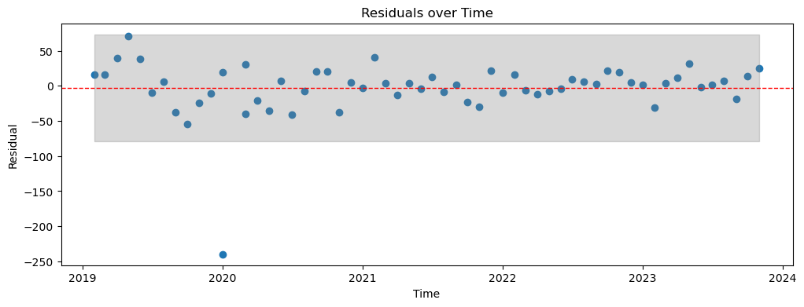 | 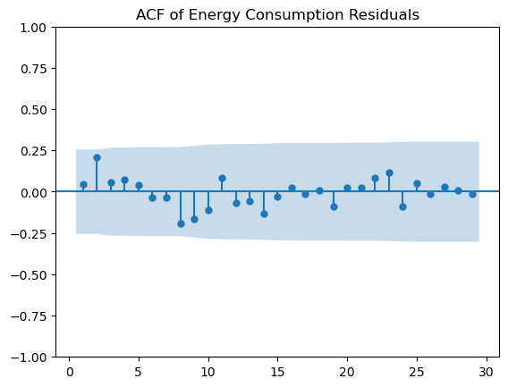
Figure 24: Diagnostic Plot of Energy Consumption SARIMA (0,0,0) (1,1,0)12
Ljung-Box Test of Residual:
Ljung-Box test statistic: 15.504
p-value: 0.905
So, null hypothesis cannot be rejected at the 0.05% level of significance. Or in other words, the residual data is independently distributed (random). There is no autocorrelation up to lag k=24 in the residual.
Figure 25: Q-Q Plot of Residual of SARIMA (0,0,0) (1,1,0)12 of Energy Consumption
Null Hypothesis (H₀): The data is normally distributed.
Alternative Hypothesis (H_{A}): The data is NOT normally distributed.
Shapiro-Wilk test statistic: 0.678
p-value: 0
So, p-value indicates that we reject the Null Hypothesis at 5% level of significance. So, the data is not normally distributed. This is also confirmed from the Q-Q plot.
From the analysis it is apparent that, the residual almost behaves like the white noise as the mean is close to zero, variance is constant and from Ljung-Box test it is evident that for the 5% level of significance the residuals do not have autocorrelation.
The forecasting graph is down below:
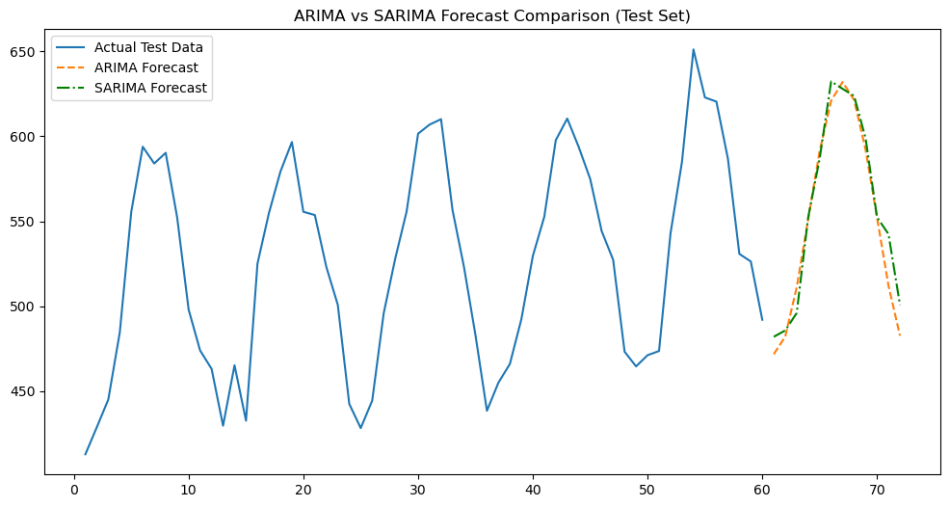
Figure 26: Forecasting of Energy Consumption with ARIMA (1,1,0) and SARIMA (0,0,0) (1,1,0)12

Part 5: Exponential Smoothing Models:
Energy Consumption Data has been taken for this analysis
SN | Model | AIC | MSE | MAE | MAPE
0 | Simple ES | 7.218049167 | 1275.868623 | 29.884945 | 5.739385
1 | Holt's Linear | 7.183006433 | 1152.481931 | 26.174326 | 5.015665
2 | HW Additive | 5.54975875 | 150.871038 | 9.649399 | 1.879398
3 | HW Multiplicative | 5.576061817 | 154.892060 | 10.060098 | 1.963113
Table 25: Comparison of ES models
Comparative Analysis: The Holt-Winters Additive model emerged as the superior model, achieving the lowest scores across all error metrics (MSE: 150.87, MAE: 9.65, MAPE: 1.88%) and the lowest information criterion (AIC: 5.55). It significantly outperformed the non-seasonal models (Simple ES and Holt's Linear), which had MSE values exceeding 1150.
Reasoning: The drastic reduction in error compared to non-seasonal models confirms the dataset contains a strong seasonal component that must be explicitly modeled. The Additive model slightly outperformed the Multiplicative model (MSE 150.87 vs. 154.89), suggesting that the magnitude of the seasonal fluctuations remains relatively constant over time rather than scaling proportionally with the trend.
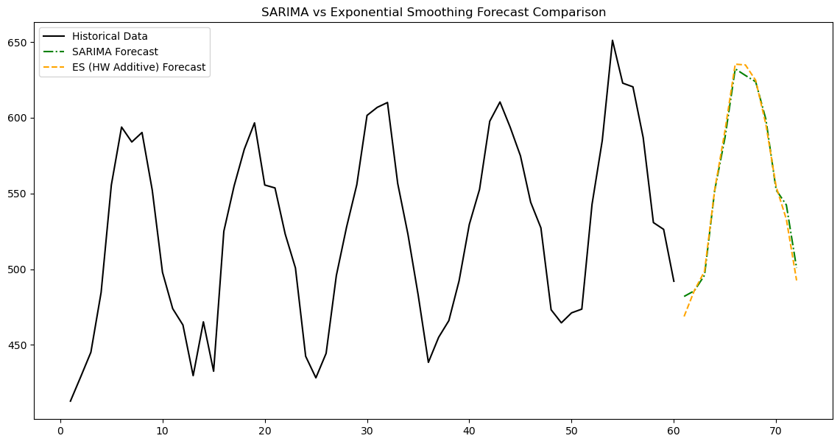
Figure 27: Forecasting of Energy Consumption with SARIMA (0,0,0) (1,1,0)12 and ES (HW Additive)
Comparison: Exponential Smoothing vs. SARIMA
The best performing model of ES and SARIMA are down below:
- Exponential Smoothing (ES): Holt-Winters Additive
- SARIMA: SARIMA (0,0,0) (1,1,0)12
Metric | SARIMA(0,0,0)(1,1,0)12 | Holt-Winters Additive | Result
AIC | 5.50 | 5.55 | SARIMA has a better (lower) fit.
RMSE | 6.76 | 12.28 | SARIMA error is ~45% lower.
Table 26: Comparison table of Best performing models of ES and SARIMA
I would trust the SARIMA (0,0,0)(1,1,0)12 model more. Because:
- Precision: The SARIMA model reduces the forecast error (RMSE) by nearly half compared to the Holt-Winters model.
- Efficiency: It achieves this higher accuracy with a lower AIC, suggesting it is capturing the true signal of the data more efficiently without unnecessary complexity.
- Specific Dynamics: While Holt-Winters smooths over the seasonal "buckets," the SARIMA model explicitly utilizes the correlation with the exact month from the previous year, which appears to be a stronger predictor for this dataset.
Forecast Accuracy & Expectations
The SARIMA (0,0,0) (1,1,0)12 provides the most accurate forecasts. It achieved the lowest Root Mean Squared Error (RMSE: 6.76) and the lowest Akaike Information Criterion (AIC: 5.50) of all models tested in this project.
Yes, this matches my expectations.
- Nature of Data: Energy consumption data typically exhibits highly regular, strong seasonality (e.g., repeating patterns every winter and summer). SARIMA models are mathematically designed to isolate and exploit these specific seasonal correlations (via seasonal differencing and autoregression).
- Model Flexibility: While Exponential Smoothing is excellent for general trends, it relies on weighted averages. SARIMA allows for more precise tuning of how past values influence future predictions. Given the clear 12-month cycle identified in the data, it is expected that a model explicitly targeting that lag would outperform a general smoothing model.

Conclusion:
The comprehensive analysis of the 60-month economic dataset (Jan 2019 – Dec 2023) revealed distinct behaviors across the four indicators:
- Retail Sales: exhibited a robust upward trend, particularly following the 2020 economic recovery. The data is non-stationary at the level but becomes stationary after first-differencing ($d=1$).
- Energy Consumption: is defined by strong, predictable seasonality without a dominant long-term trend. The 12-month cycle is consistent, peaking in specific seasons (likely summer/winter due to heating/cooling demands).
- Stock Price Index: showed a general upward drift but behaved largely as a "Random Walk," making it difficult to predict based solely on past values. This suggests the market is relatively efficient.
- Unemployment Rate: displayed significant volatility, particularly during early 2020, but has since stabilized. This series required differencing to stabilize its mean.
Best Model Selection
Based on the diagnostic metrics (AIC, BIC) and forecast accuracy (RMSE) on the test set, the following models were selected as the most robust:
Time Series | Best Model | Justification
Retail Sales | ARIMA (0,1,1) with Drift | The drift term captures the strong upward trend, while the Moving Average (MA) term accounts for short-term shocks. (Note: The initial ARIMA (6,1,6) was rejected due to overfitting).
Energy Consumption | SARIMA (0,0,0) (1,1,0)12 | Significantly outperformed standard ARIMA and Holt-Winters. By explicitly modeling the seasonal lag (12 months), it reduced forecasting error (RMSE) by nearly 50%.
Stock Price Index | ARIMA (0,1,0) | A "Random Walk" model was the most effective. Complex models failed to extract meaningful patterns from the noise, consistent with the Efficient Market Hypothesis.
Limitations of the Analysis
- Sample Size: The dataset consists of only 60 observations (5 years). This is the bare minimum for seasonal modeling (capturing only 5 full cycles), which limits the statistical power of the SARIMA estimates.
- Univariate Scope: The analysis relied solely on the past history of each variable. It did not account for exogenous factors (e.g., interest rates affecting Stock Prices, or temperature affecting Energy Consumption).
- Structural Breaks: Standard ARIMA models assume constant parameters, which can lead to forecast errors when historical relationships change abruptly or experience shock.
Recommendations
- Use SARIMA for Operational Planning: The Energy Consumption model is highly reliable. Utilities and grid operators can use the SARIMA (0,0,0) (1,1,0)12 forecasts for short-term capacity planning.
- Frequent Re-estimation: Given the short history and potential for economic shifts, models should be re-training every 3-6 months as new data becomes available.
- Future Multivariate Analysis: To improve Stock Price and Unemployment forecasts, future iterations should explore Vector Autoregression (VAR) or Dynamic Regression models that include leading economic indicators (e.g., interest rates, inflation).

References:
Course Materials & Data
Karim, M. R. (2025). Class Lecture: DSA5021: Time Series Analysis and Forecasting. Department of Statistics and Data Science, Jahangirnagar University.
Karim, M. R. (2025). Time series analysis course project: Project_Fall_2025tex.pdf. Department of Statistics and Data Science, Jahangirnagar University.
Karim, M. R. (2025). Economic indicators dataset (2019-2023). Department of Statistics and Data Science, Jahangirnagar University.
Statistical Tests (Original Papers)
Dickey, D. A., & Fuller, W. A. (1979). Distribution of the estimators for autoregressive time series with a unit root. Journal of the American Statistical Association, 74(366), 427–431. https://doi.org/10.2307/2286348
Kwiatkowski, D., Phillips, P. C. B., Schmidt, P., & Shin, Y. (1992). Testing the null hypothesis of stationarity against the alternative of a unit root. Journal of Econometrics, 54(1–3), 159–178. https://doi.org/10.1016/0304-4076(92)90104-Y
Ljung, G. M., & Box, G. E. P. (1978). On a measure of lack of fit in time series models. Biometrika, 65(2), 297–303. https://doi.org/10.1093/biomet/65.2.297
Software & Libraries
McKinney, W. (2010). Data structures for statistical computing in Python. In S. van der Walt & J. Millman (Eds.), Proceedings of the 9th Python in Science Conference (pp. 56–61).
Seabold, S., & Perktold, J. (2010). statsmodels: Econometric and statistical modeling with Python. In S. van der Walt & J. Millman (Eds.), Proceedings of the 9th Python in Science Conference (pp. 92–96).
LLMS:
Google. (2025). Gemini (Dec 10 version) [Large language model]. https://gemini.google.com/
OpenAI. (2025). ChatGPT (Dec 10 version) [Large language model]. https://chat.openai.com/

